**Nama : Wiwin Nur Kholifah  
NIM : 18090030  
Kelas : 5C**

1. **Source Code**ModelUser.php 🡪 application/ model

ModelBuku.php 🡪 application/model

autoload.php 🡪 application/config

database.php 🡪 application/config

1. **Database**  
   a. user  
   b. role  
   c. kategori  
   d. buku
2. **Capture Hasil**

* user

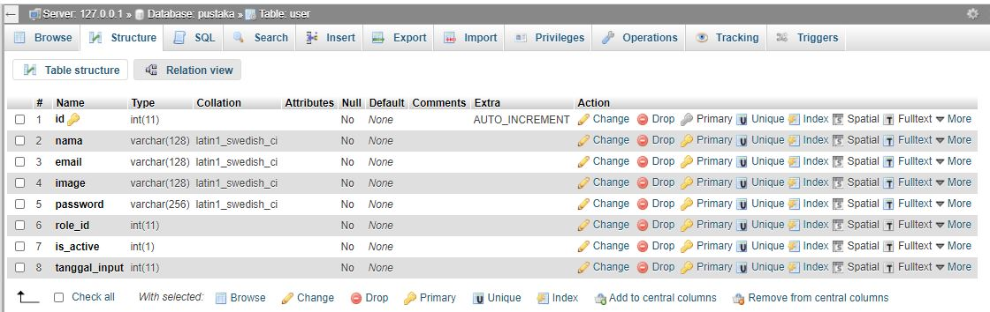

* role

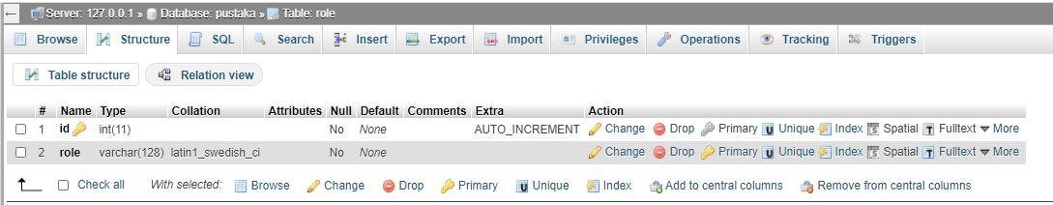

* kategori

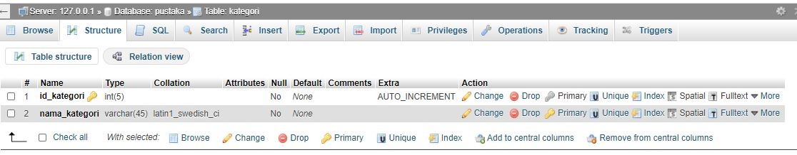

* buku

